Thermal Model of a Li-ion Battery

Determining the heat transfer of a battery on its surroundings.

Jacob Turner

ENGR 421

5/16/2019

Introduction

Lithium-ion batteries are an indispensable technology that have come to power a significant amount of the productivity in the 21st century. One critical parameter important to the performance of lithium-ion batteries is the temperature gradient under a load ("Discharging at High and Low Temperatures" 2019). The thermal conditions of the environment and the temperature gradient of the battery cell have a large influence on the overall performance and energy storage of a Lithium-ion battery. Hence, it will be useful to understand the thermal affects of a battery on its environment while it is under a constant discharge. A battery that runs too cold will risk a drastic increase in internal resistance, which can decrease the overall capacity and length of runtime of the battery ("Discharging at High and Low Temperatures" 2019). Alternatively, running too hot can permanently shorten its lifetime, in addition, high temperatures can potentially damage other electronic components that are in proximity.

A python program was created using the FeniCS module and other libraries to create a thermal model of a 3D Lithium-ion battery cell under a constant discharge. The model will help to understand which parameters the largest effect on the temperature gradient within the battery cell have, as well as how these affect the performance. Gaining insight into this behavior could help one to create more thorough thermal battery management systems to help improve the efficiency of electric vehicles and other devices. Lastly, a sensitivity analysis will be performed on the current discharge rate, internal resistance of the battery, voltage variation with temperature, and the volume to help in understanding how the uncertainty in these values affect the heat transfer with the surroundings of the battery cell.

Literature Review

Lithium-ion batteries have become immensely important over the last few decades with the introduction of various portable electronic devices from smart phones to electric vehicles. This has caused a surge of interest in the scientific community in the thermal behavior of the battery cells to optimize the energy storage and performance of these electronic devices. The performance of Li-ion battery systems is dependent on the thermal behavior and temperature gradient uniformity inside the cell (Wang, Ma, and Zhang, 2017). This has caused many researchers to embark on creating models to help in thoroughly understanding this behavior. One paper title, “Finite Element Thermal Model and Simulation for a Cylindrical Li-ion Battery”, by Zhenpo Wang, Jun Ma, and Lei Zhang aimed at validating the thermal model they created using finite element analysis with empirical experimentation and verifying the accuracy of the simulation method. Overall, the results of this research was able to narrow the total error deviation from temperature in the simulation down to approximately 9 -11 % compared to the empirical experiment. Another paper titled, “Battery Electrical Vehicles-Analysis of Thermal Modelling and Thermal Management” by Ahmadou Samba created a similar model in ANSYS except in two dimensions and it aimed at exploring the impact of battery geometry and design on the performance of the battery cell. This paper also discussed one of the possible consequences of allowing the internal temperature of a battery to get too hot. A diagram depicting the risk of this happening with the internal temperature of the battery can be seen in Figure 1 on the following page.

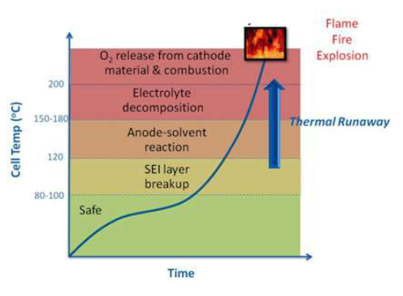

Figure . Diagram depicting the escalation of a thermal runaway event (Ahmadou Samba, 2015)

The diagram above shows how lithium-ion batteries can ultimately catch on fire or even explode in the event of a thermal runaway. A safe temperature range for batteries to be running at is between 80 – 100 (Ahmadou Samba, 2015). The simulation results for this research paper produced temperatures that were within about 7% of the empirical experimental results. It also showed that a higher current discharge rate of the battery prevented the battery from dissipated as much heat near the tabs or the anode of the battery.

Methodology

A system of partial differential equations (PDE) closely resembling the heat equation can be used to model the thermal behavior of a lithium-ion battery cell over a specified time interval. Finite Element Analysis (FEA) can be used to create a computational model with python using the FEniCS module to solve the relevant PDE. FEA can be used to solve and model PDE’s by reducing the number of sections or elements of an object to a finite number, this is done by creating a mesh across the domain of the object. The relevant PDE can be computed to determine the solution across each element of the object in time and space. Ultimately, this allows a working simulation to model a physical phenomenon that are described by the relevant PDE’s. FEA is often used to model physical problems in structural analysis, heat transfer, fluid dynamics, mass transport, and even electromagnetic potential.

Finite element analysis was used to accurately model the thermal behavior of a lithium-ion battery cell under a constant discharge over time. The primary tools used were the python language and the FEniCS module to aid in solving the PDE and running the simulation. Paraview was also used to create the visualizations and videos of the simulation. The relevant PDE’s to describe the thermal behavior of a Li-ion cell under discharge were based on the heat equation and derived largely from experimentation, which were obtained from the paper entitled, *Finite Element Thermal Model and Simulation for a Cylindrical Li-ion Battery.* The relevant PDE along with its boundary conditions and heat generation function can be seen in Equations [1] – [6] (Ahmadou Samba, 2015).

[1]

[2]

[3]

[4]

[5]

[6]

Where,

– Internal Temperature of the battery cell (C)

– Heat generation rate as a function of temperature ()

– Average battery cell density ()

– Specific heat capacity of the battery ()

– Thermal conductivity in the x and y direction ()

– Constant discharge current of the battery (Amps)

– Volume of the battery cell ()

– Internal resistance of the battery cell (Ohms)

– Coefficient of voltage variance with temperature ()

Equation [1] of the system is derived from the general heat equation and it describes the heat transfer through the material. The first term on the left () describes the time dependency of the thermal behavior of the battery. Specifically, how the temperature throughout the battery changes with time proportionally to the specific heat () and the average density () of the battery cell core. The second term in Equation [1] is the Laplacian of the temperature distribution () throughout the cell in two dimensions with a coefficient of the thermal conductivity () of the battery cell core. Lastly, the heat generation function acts as the heat source within the battery cell along the boundaries of the cathode of the battery. The heat generation function is dependent on the current, internal resistance, volume and temperature of the battery. The battery will be placed in an electric vehicle next to similar boundaries on the left and right hand side. Therefore, the battery cell will experience a higher temperature on the left and right side of the battery causing the boundary conditions to have higher value Dirichlet conditions in these locations. The top and bottom of the battery will be exposed to their respective ambient temperatures and therefore these boundaries will have Dirichlet conditions, where the top of the battery is exposed to the internal temperature of a car and the bottom the external temperature. A diagram showing the Dirichlet and Neumann boundaries labeled along the battery domain can be seen below in Figure 1.

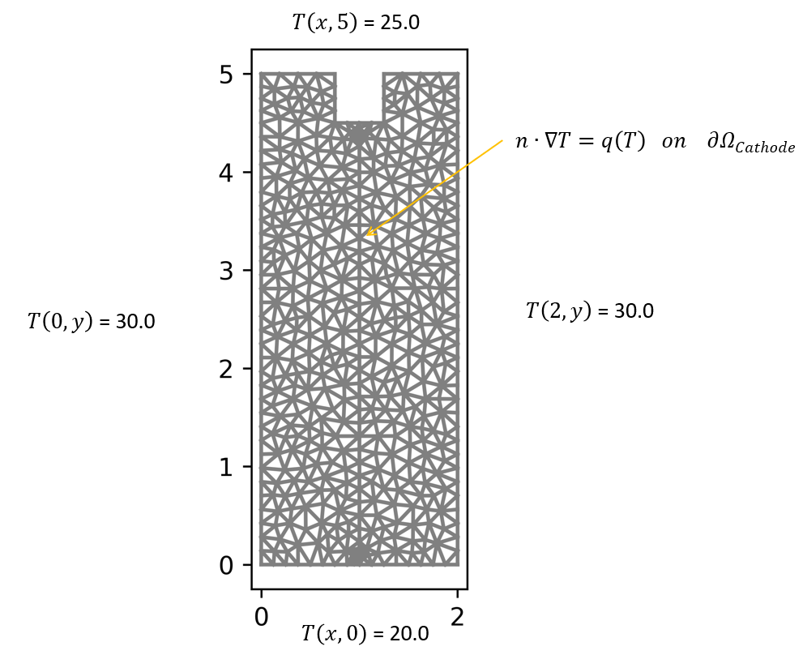

Figure 2. Battery domain marked with their respective Dirichlet and Neumann boundaries.

The derivation of the weak formulation is shown step by step below in equations [7] – [11] starting with the relevant PDE describing heat transfer through the battery.

[7]

We begin by multiplying by the test function () and integrating.

[8]

In order to convert the second order derivatives to we can use the following identity from the divergence theorem to create first order derivatives.

[9]

[10]

The previous identity can be substituted into the last term to create the boundary term.

[11]

The final variation form can be seen below in equation [12].

[12]

Both the test and trial space are defined as follows.

Test Space: Trial Space:

Results and Discussion

The total power lost to the surroundings of the battery over the simulation was about 54.10 Watts, where about 80% of the total power was lost from the left and right boundaries. Significantly lower amounts of power were transferred through the top boundary, the tab domains, and the bottom boundary. Multiple frames of the heat distribution throughout the battery domain as well as a plot of the temperature across the battery can be seen below in Figures 2-4.

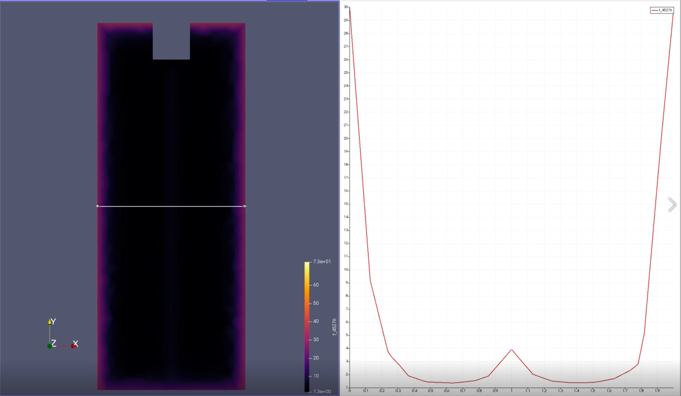

Figure 3. Paraview visualization of the heat distribution across the battery domain in degrees Celsius at t = 0.0 seconds.

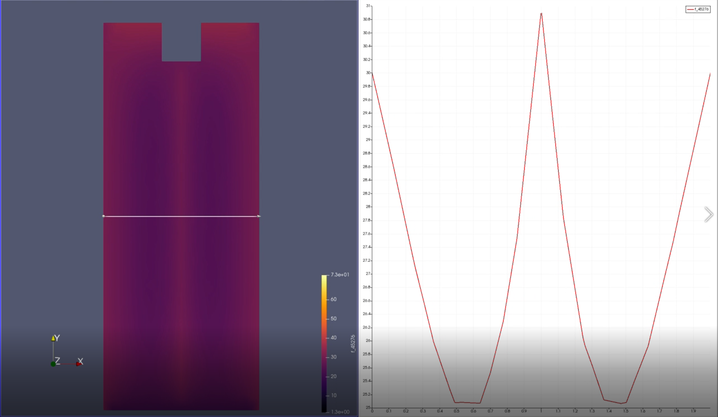

Figure 4. Heat distribution throughout the battery domain after 2 seconds of constant current discharge.

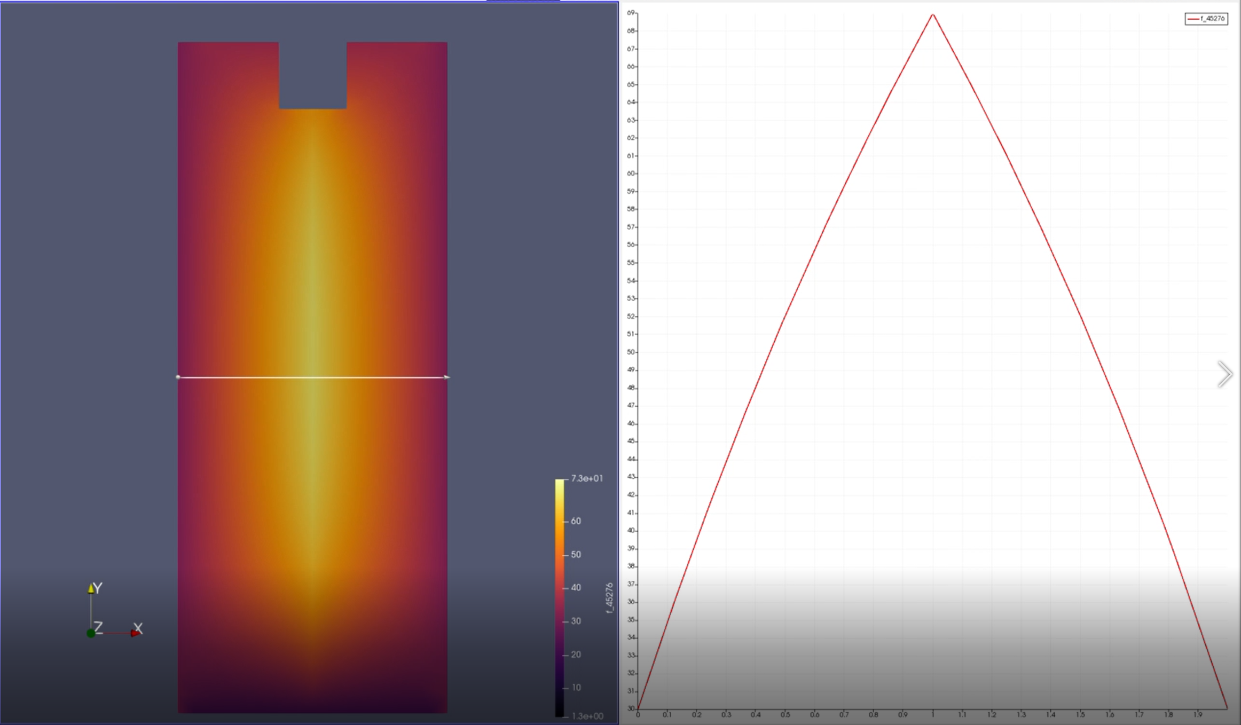

Figure 5. Battery simulation after reaching thermal equilibrium with constant current discharge.

A sensitivity analysis was also performed on the battery simulation to investigate the uncertainty surrounding many of the battery cells parameters. The cell parameters that were investigated include the current discharge rate, coefficient of voltage variation with temperature, internal resistance, and the cell volume. The parameters were investigated because they have the most direct relationship to the heat generation function and thus may influence the transfer of power to its surroundings the most. The results of the sensitivity analysis can be seen below in Figure 2. The results show that the current has the largest affect on the power loss of the battery through its boundaries, seconded by the size of the battery. This makes sense because with a smaller battery the heat will travel a smaller distance to reach any given boundary. The effect of the current discharge rate on the power transfer also makes sense because of the exponential relationship between power and current in circuits (). This relationship also explains the linear relationship that the internal resistance has on the power transfer to the battery surroundings.

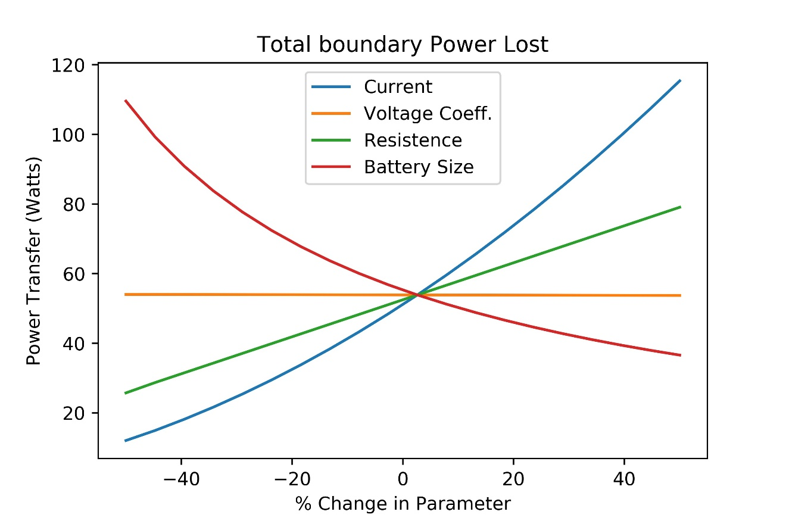

Figure 6. Investigating the uncertainty around the current, voltage coefficient, resistance, and battery size.

Lastly, the coefficient of voltage variation has the smallest effect on the power transfer to the surroundings of the battery cell. The relationship in the figure above appears to be a flat line, however, it actually has a very small negative slope that does not seem obvious by inspection.

Conclusions

Ultimately, the python program determined that approximately 54.10 watts of power are lost through the boundaries of the battery as heat flux. In addition, about 80% of the heat lost as power was through the left and right boundaries compared to the top and bottom boundaries of the battery. The sensitivity analysis also investigated the uncertainty surrounding the main heat generation parameters. This showed that the current discharge rate and the size of the battery had the largest affects on the total power lost as heat flux through its boundaries. However, the current discharge rate would be the most efficient parameters to invest research and development resources into lowering so that the battery could be made more efficient. Though, lowering the discharge rate of the battery may have unwanted side effects and may prove quite difficult because of the current demands of the device that the battery is powering. The internal resistance of the battery also had a large effect on the power loss of the battery. Therefore, lowering the internal resistance of the battery may also be an efficient option to invest research and development resources because it is easier to lower the resistance in a battery and it has less implication on the device the battery is powering. Lastly, if more research were conducted on this battery simulation model with finite element analysis, I would suggest making the battery into a 3D cylinder so that it is more realistic when compared to the Tesla vehicle battery cells. I would also increase the run-time of the simulation and add a capacity parameter to the battery so that multiple battery cycles could be run in the simulation and the depletion of the energy in the battery could be investigated for its effect on the power transfer. The last recommendation would be to investigate the relationship between the internal resistance of the battery as a function of the temperature of the cathode of the battery. This would be an important factor to investigate because internal resistance can be affected significantly by large changes in temperature due to the expansion of the material.

References

1. "Discharging at High and Low Temperatures." (2019). *Batteryuniversity.com*, <https://batteryuniversity.com/learn/article/discharging_at_high_and_low_temperatures> (Apr. 4, 2019).
2. Ahmadou Samba. 2015. Battery Electrical Vehicles-Analysis of Thermal Modelling and Thermal Management . Electric power*. LUSAC Université de caen Basse Normandie*; Vrije Universiteit Brussel, English.
3. Wang, Z., Ma, J., and Zhang, L. (2017). “Finite Element Thermal Model and Simulation for a Cylindrical Li-Ion Battery.” *IEEE Access*, 5, 15372–15379.